8. Biodiversity

Breakfast club activities
Eco-Schools activities can be done at any time of the school day. Eco-Schools worked with teachers and breakfast club leaders from schools in receipt of Greggs Breakfast Club Grant to develop activity ideas for each of the nine topics ideal for pupils in breakfast clubs before school.

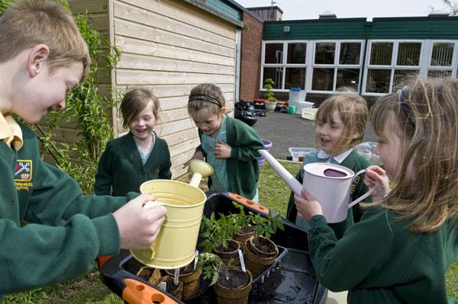
A bugs Breakfast
- Plant up planters or plant pots with flowers that bees and butterflies will love. Buddleia, Verbena and Lavender are butterfly favourites. Put them outside the door nearest to the breakfast club room and have the pupils water them to make sure that the bugs get their breakfast too

- In the winter remember that birds want their breakfast too… so make it a job for the breakfast club pupils to fill up the bird feeders. Maybe hang some near the windows of breakfast club so that the children can bird watch. Can they identify the birds that come to the feeders? You may get; blackbirds, blue tits, great tits, greenfinches, house sparrows, robins, starlings or another species of bird we haven’t spotted yet at your bird feeder in the morning.

