7. Energy

Breakfast club activities
Eco-Schools activities can be done at any time of the school day. Eco-Schools worked with teachers and breakfast club leaders from schools in receipt of Greggs Breakfast Club Grant to develop activity ideas for each of the nine topics ideal for pupils in breakfast clubs before school.

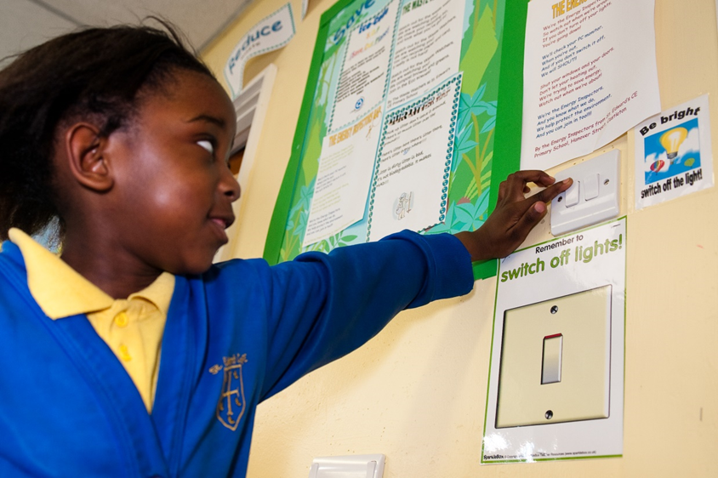
Switch off Tuesday
How many items that use energy can you switch off on a Tuesday?
- Eat bread not toast
- Switch off the white board and play board games instead
- No access to the ITC suite
- Switch off the lights
- Make your own music, singing and playing instruments
- Play traditional games
How many items can you switch off one day a week and use no energy at all at breakfast club

