9. Global Citizenship

Breakfast club activities
Eco-Schools activities can be done at any time of the school day. Eco-Schools worked with teachers and breakfast club leaders from schools in receipt of Greggs Breakfast Club Grant to develop activity ideas for each of the nine topics ideal for pupils in breakfast clubs before school.

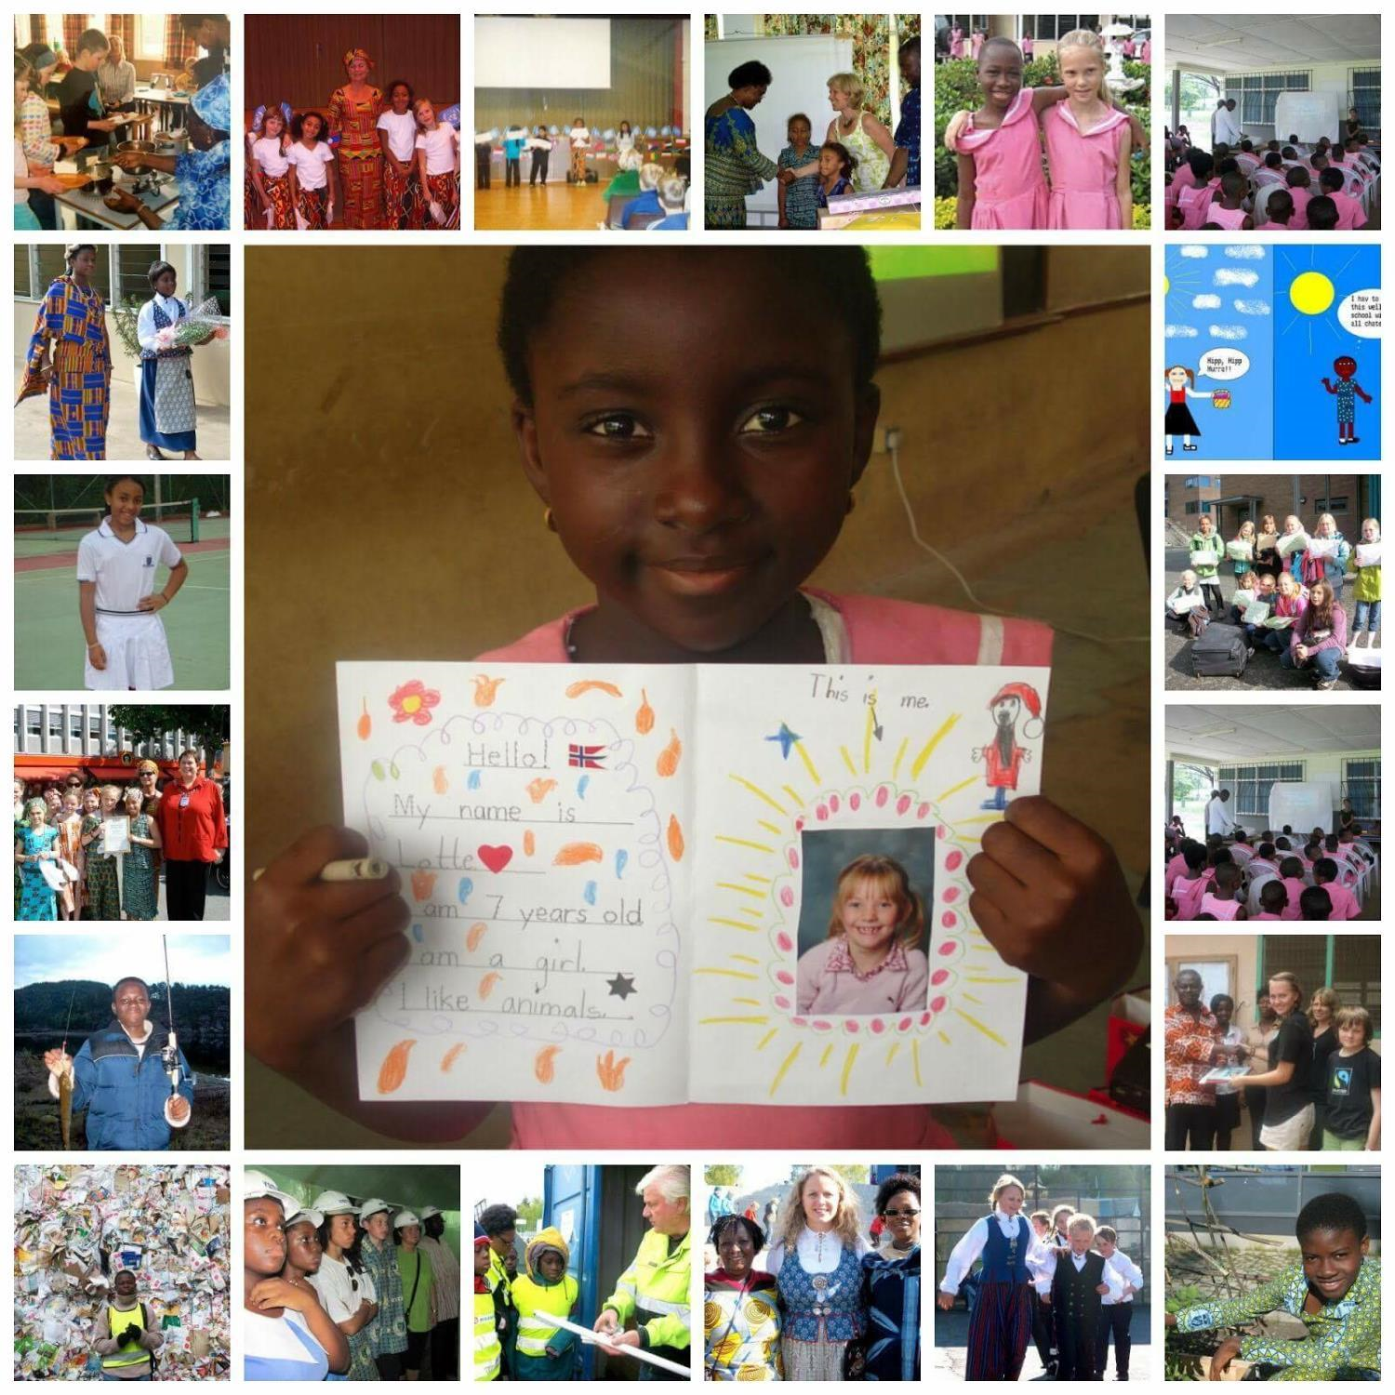
“Before you finish eating breakfast in the morning, you’ve depended on more than half of the world.” Martin Luther King Jr
- Learn how to say “Good Morning” in a different language each week... until you can start the day anywhere in the world. “Habari za asubuhi” means “Good morning” in Swahili a language spoken in Tanzania, Kenya and other East African Countries.
- Have breakfast from another country one day a week. Get the pupils to research what people eat for breakfast around the world. For example could they have a chocolate croissant from France, a bagel from Israel, Vegemite from Australia on toast, savoury salad like some people Turkey or Fruit, toast and ham like some people in Brazil.
In the picture to the left a little girl who lives in Ghana is learning all about Norway as part of the Global Citizenship topic of Eco-Schools. Could your breakfast club find a way to communicate with children in another country? Remember that at 8:00am before the school day has even started in Wigan in the UK it is 4:00pm in Novosibirsk in Russia and their school day has already finished, so if you plan to Skype another country they may already have left school.

