6. Healthy Living

Breakfast club activities
Eco-Schools activities can be done at any time of the school day. Eco-Schools worked with teachers and breakfast club leaders from schools in receipt of Greggs Breakfast Club Grant to develop activity ideas for each of the nine topics ideal for pupils in breakfast clubs before school.

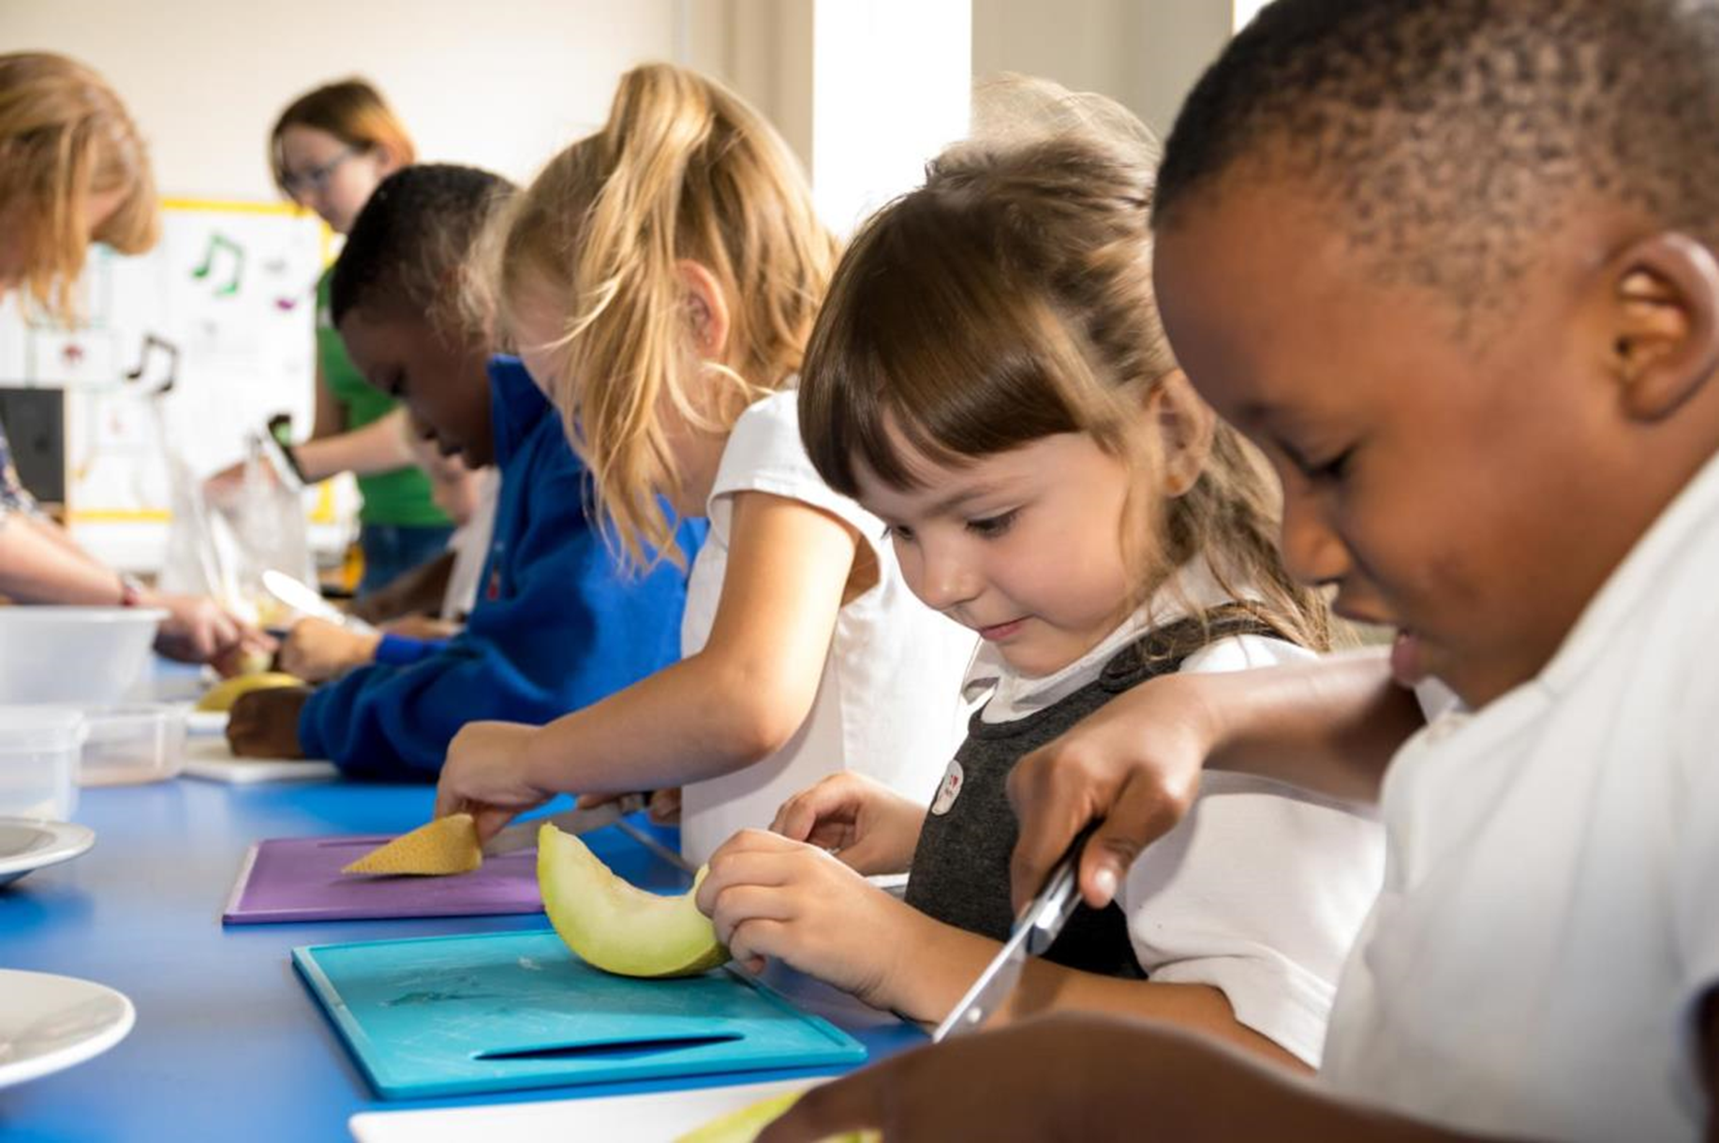
A healthy start to the day
- Get pupils to bring their tooth brush to breakfast club and brush their teeth after breakfast
- Friday fruit day, make sure everyone eats some fruit on Friday… or First of Five, Friday fruit… make sure that everyone has their first of five pieces of fruit
- 1 mile challenge – could everyone in breakfast club run a mile. Measure out a mile long route in the playground, how many times rounds the edge do you have to run to go a mile
- Download a Zumba tutorial to show on the white board and get everyone up and dancing in the morning

As the breakfast club are in school nice and early they are in an ideal position to help the whole school start the day in a healthy way. For example they could help prepare a “Bikers breakfast” for children who get to school by bike. Can they think of something healthy to serve?

