5. School Grounds

Breakfast club activities
Eco-Schools activities can be done at any time of the school day. Eco-Schools worked with teachers and breakfast club leaders from schools in receipt of Greggs Breakfast Club Grant to develop activity ideas for each of the nine topics ideal for pupils in breakfast clubs before school.
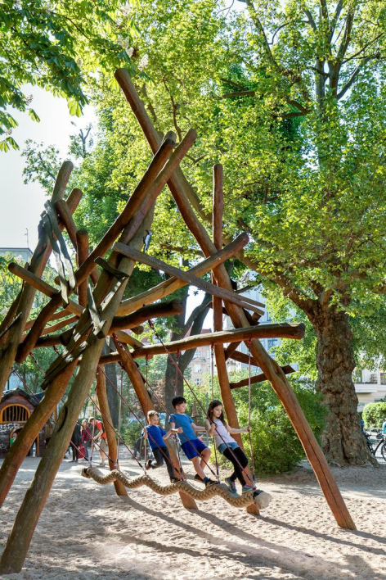

“How sweet the morning air is!”

― Arthur Conan Doyle, Sherlock Holmes: The Complete Novels and Stories, Volume I
- Watering any plants is lovely morning activity… is there a school garden that could do with being watered every morning in the summer? Pupils will love being chosen to do this special job, it is especially fun if they can get the water from a rain water harvesting water butt.
- Put any breakfast club fruit waste out and into the compost bins (remind the pupils to say “hello” to the worms when they give them their breakfast)
- Ask the children to design the best possible play ground for wildlife and the environment. This is a great activity for children to work together on a large piece of paper.
Is it possible to make an area of the school playground accessible to the breakfast club so that pupils can run around and enjoy being outdoors before school starts?

