1. transport

Breakfast club activities
Eco-Schools activities can be done at any time of the school day. Eco-Schools worked with teachers and breakfast club leaders from schools in receipt of Greggs Breakfast Club Grant to develop activity ideas for each of the nine topics ideal for pupils in breakfast clubs before school

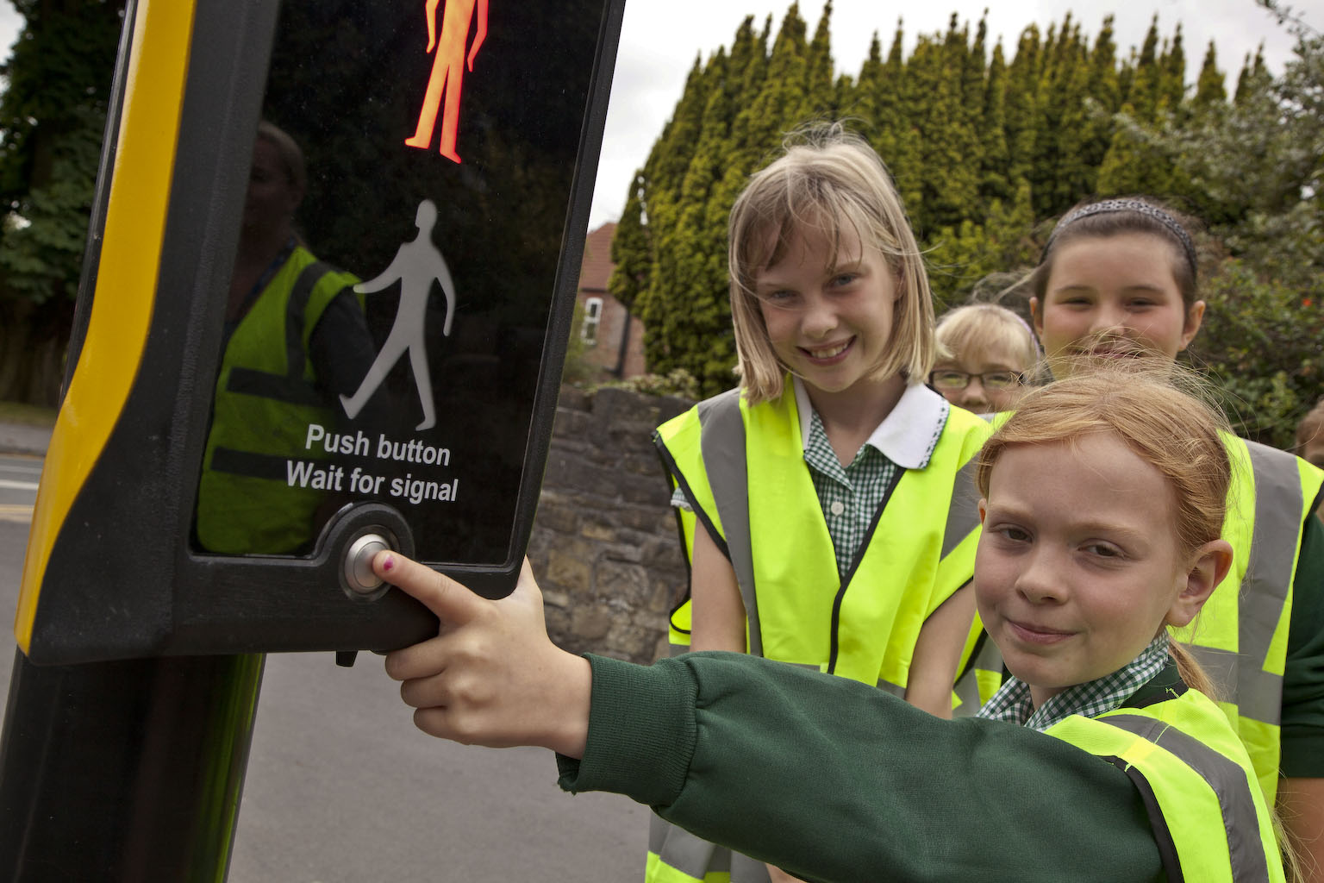
Alert and ready to learn
Breakfast club is a great place to think about how pupils travel to school
- Encourage breakfast club pupils to walk or cycle to school
- Breakfast club pupils can survey how other pupils are getting to school in the morning
- Breakfast club attendees can give a sticker to other pupils in the school who have travelled a healthy way
- Create high-vis fashion to promote road safety when getting to and from school in the dark… (Scrap stores can be great places to get lots of craft materials for pupils to get creative with).
How many different ways can your breakfast club come up with to encourage healthy travel? Can they draw posters, tell their class, or prepare an assembly for the whole school?

