2. Waste

Breakfast club activities
Eco-Schools activities can be done at any time of the school day. Eco-Schools worked with teachers and breakfast club leaders from schools in receipt of Greggs Breakfast Club Grant to develop activity ideas for each of the nine topics ideal for pupils in breakfast clubs before school.

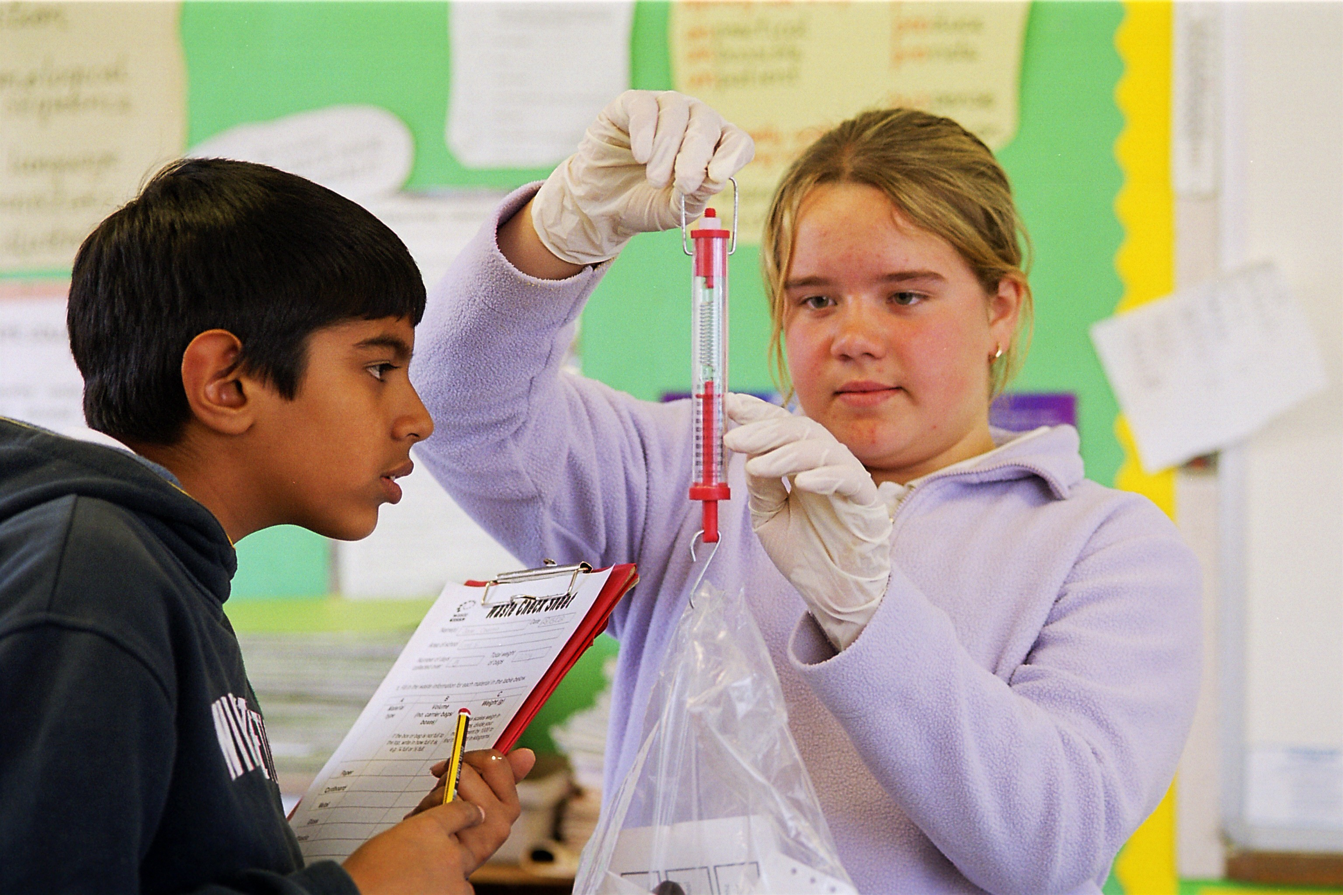
Waste free breakfast club
- Crust Champion; make a special treat for the pupil that eats to crust to make sure that they are not thrown in the bin. For example allowing them to stand at the front of the line when they leave breakfast club
- Make sure that your cereal boxes and been tins from breakfast club get recycled
- Collect all the cereal boxes from breakfast club and on the last day of term use them for some extra creative junk modelling
- Could pupils pre-order breakfast to reduce waste
- Get the pupils to vote on their favourite cereal to make sure it is all eaten
With lots of pupils having breakfast together, breakfast clubs are a very low waste activity, maybe pupils could weigh all the rubbish created at breakfast club to find out?

