
3. Water

Breakfast club activities
Eco-Schools activities can be done at any time of the school day. Eco-Schools worked with teachers and breakfast club leaders from schools in receipt of Greggs Breakfast Club Grant to develop activity ideas for each of the nine topics ideal for pupils in breakfast clubs before school.

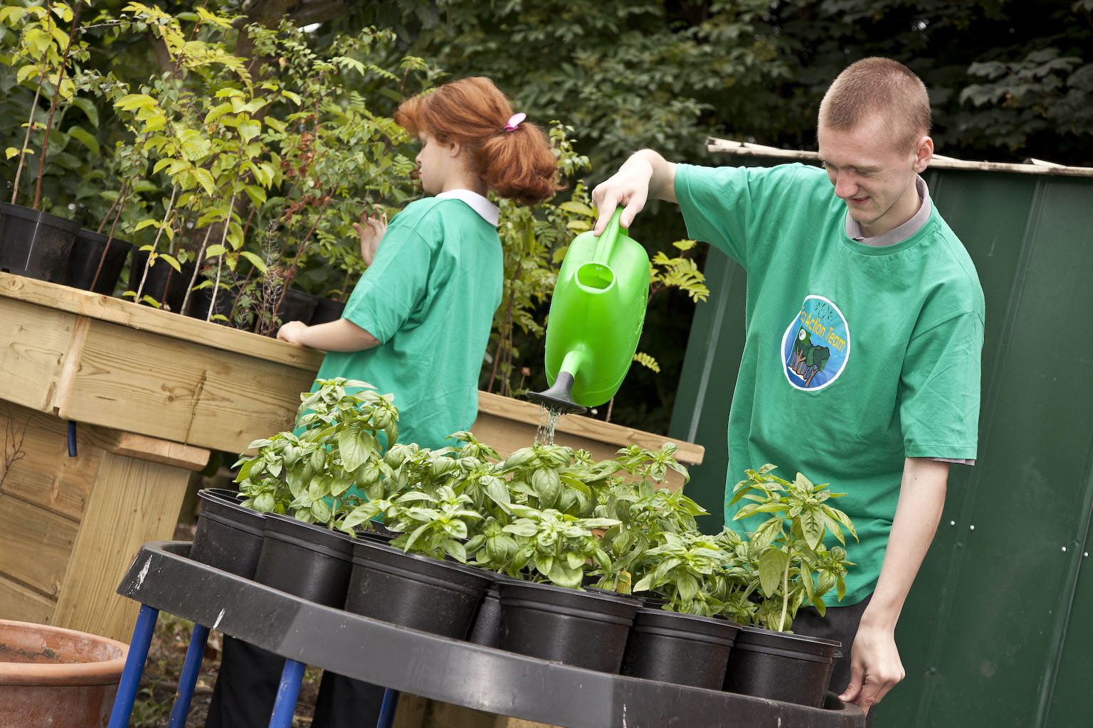
Water water everywhere
Can your breakfast club make a big splash?
- Use water from the water-butt to water houseplants in school
- Every child who drinks a cup of water gets a blue sticker
- Look up a an amazing water fact to share
- Make sure all the taps are switched off after everyone washes their hands.
The water topic lends itself to lovely art projects, could your pupils make a mobile about the water cycle out of recycled materials. Older pupils at breakfast club can explain the water cycle to younger ones.

