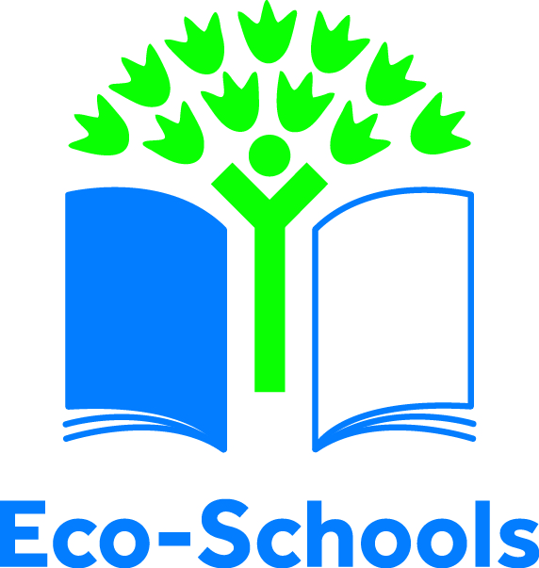

Early Years Pupils
Environmental Review

This is a simple environmental review covering all nine of the Eco-Schools topics designed for early year’s pupils. Pupils will need help from adults and work in groups to complete this review.

This review is designed to start discussions about the Eco-Schools topics with young pupils. The answers to the review might help your Eco-Committee choose which Eco-Schools topics they want to work on.

Name of school/Nursery

Date carried out

Staff contact

Name and age of children

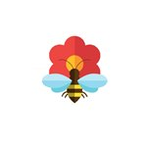

Biodiversity
 | Yes | No
Does your school have a nature area?

Does your school have school pets? Maybe chickens, goldfish or other animals

Have you seen any bugs in the playground?

Pupil’s Comments:
If you have answered no to any of these questions then you might want to choose the biodiversity topic

Energy
 | Yes | No
Are lights always switched off when you leave a classroom?
Are windows open when the radiators/heaters are on?

Pupil’s Comments:
If you answered no to any of these questions you might want to choose the energy topic

Global Citizenship
 | Yes | No
Have you learnt about any other countries in class?

Can anyone in your class say “hello” in another language?
Pupil’s Comments:
If you answered no to any of these questions you might want to choose the global perspectives topic

Healthy Living
 | Yes | No
Do you run, jump or dance every day?

Can you get a drink of water whenever you like?
Do you eat fruit and vegetables at school?
Pupil’s Comments:
If you answered no to any of these questions you might want to choose the healthy living topic

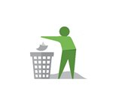

Litter
 | Yes | No
Is the playground clean and free from litter?

Are there enough bins at school?
Have you done a litter pick?
Pupil’s Comments:
If you answered no to any of these questions you might want to choose the litter topic

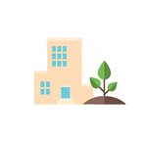

School Grounds
 | Yes | No
Do you play outside every day?

Do you grow plants at school?
Pupil’s Comments:
If you answered no to any of these questions you might want to choose the school grounds topic

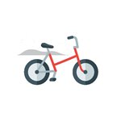

Transport
 | Yes | No
Is there a problem with cars outside your school/nursery before school starts and at home time?

Do pupils walk/cycle or take public transport to school where possible?

Does your school/nursery have dry and secure storage for bikes and scooters?

Pupil’s Comments:
Please note that if you have answered no to most of the questions then you need to work out how to improve transport to school

Waste
 | Yes | No
Reduce
Do you use both sides of the paper

Do you have a reusable water bottles?
Reuse
Does your school run book or toy swaps?

Recycle
Can you put paper in the recycling bin?

Compost
Does your school have a compost bin?

Pupil’s Comments:
If you answered no to any of the questions you might want to choose the waste topic

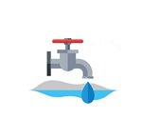

Water
 | Yes | No
Do you always remember to turn off taps after you’ve used them?

Does your school collect rain water?
Pupil’s Comments:
If you answered no to any of the questions you might want to choose the water topic

