**Action Plan**

**Date:**

Eco-Schools Topic:

Action(s):

How we will monitor progress:

Evaluation:

How long will it take?

Aim:



Who is responsible?

Action(s):

How we will monitor progress:

Evaluation:

How long will it take?

Aim:



Who is responsible?

Eco-Schools Topic:

Action(s):

How we will monitor progress:

Evaluation:

How long will it take?

Aim:



Who is responsible?

Eco-Schools Topic:



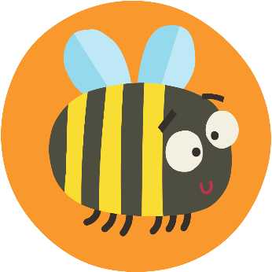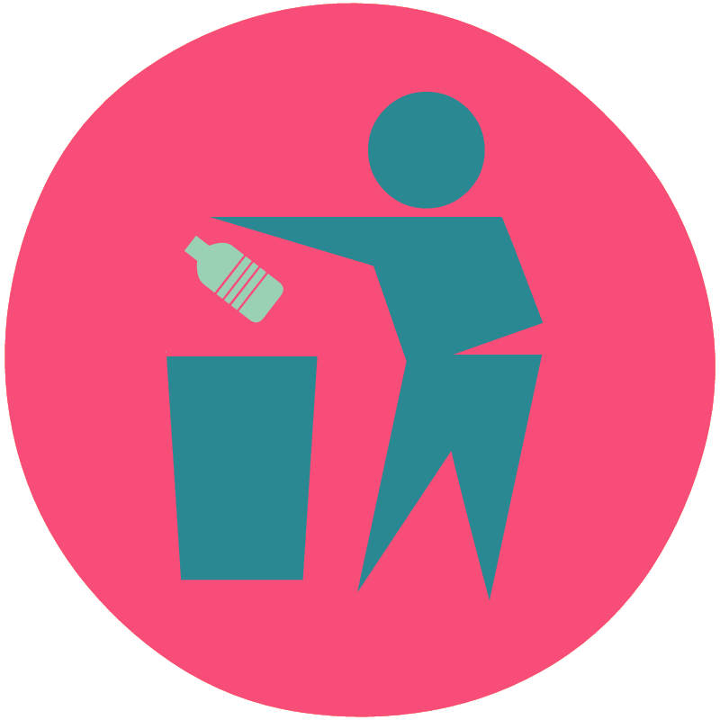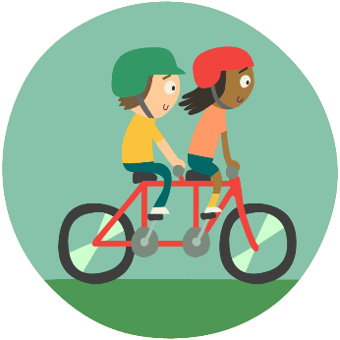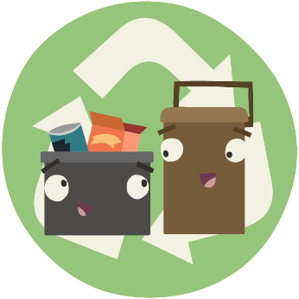

Eco-Schools Topic:

Action(s):

How we will monitor progress:

Evaluation:

How long will it take?

Aim:



Who is responsible?

Action(s):

How we will monitor progress:

Evaluation:

How long will it take?

Aim:



Who is responsible?

Eco-Schools Topic: