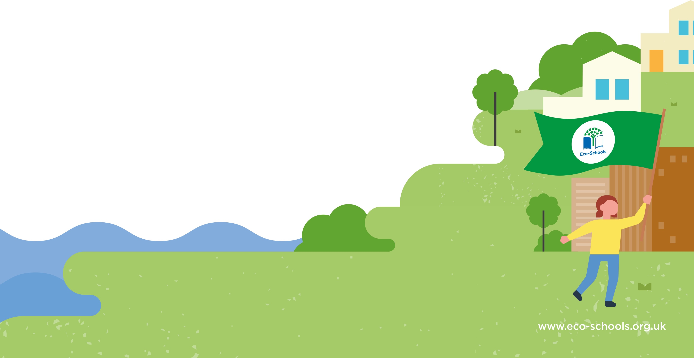



**Date:**

Eco-Schools Topic:

Action(s):

How we will monitor progress:

Evaluation:

Aim:

How long will it take?

Who is responsible?

Eco-Schools Topic:

Action(s):

How we will monitor progress:

Evaluation:

Aim:

How long will it take?

Who is responsible?

Eco-Schools Topic:

Action(s):

How we will monitor progress:

Evaluation:

Aim:

How long will it take?

Who is responsible?

**Action Plan**





Eco-Schools Topic:

Action(s):

How we will monitor progress:

Evaluation:

Aim:

How long will it take?

Who is responsible?

How long will it take?

Who is responsible?

Aim:

How we will monitor progress:

Evaluation:

Action(s):

Eco-Schools Topic:

**Action Plan**